Image 1: Cause and Effect Diagram

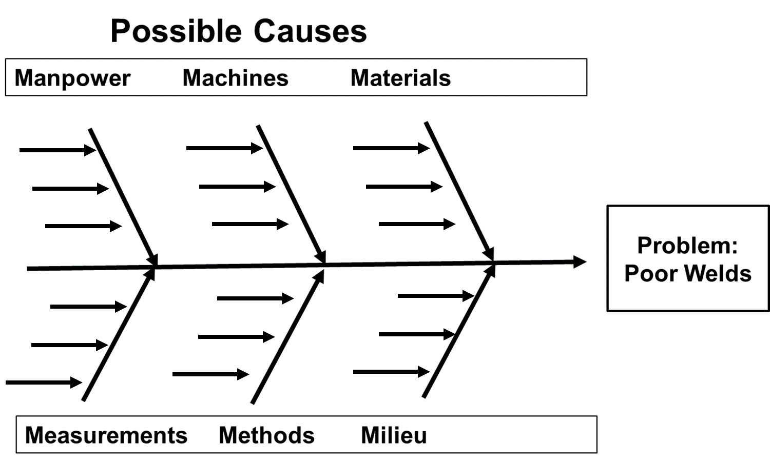

Image 2: Check Sheet

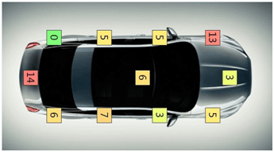

Image 3: Flowchart

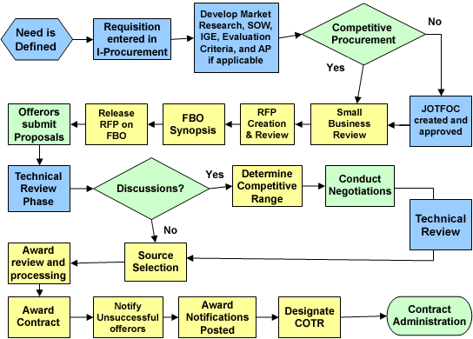

Image 4: Histogram

Histogram Raw Data
Measure Value | Frequency
2579 | 1
2580 | 0
2581 | 1
2582 | 1
2583 | 1
2584 | 1
2585 | 0
2586 | 0
2587 | 2
2588 | 2
2589 | 2
2590 | 2
2591 | 2
2592 | 1
2593 | 2
2594 | 1
2595 | 2
2596 | 3
2597 | 4
2598 | 5
2599 | 5
2600 | 8
2601 | 6
2602 | 4
2603 | 3
2604 | 2
2605 | 0
2606 | 0
2607 | 3
2608 | 1
2609 | 0
2610 | 1
2611 | 1
2612 | 0

Image 5: Pareto Chart

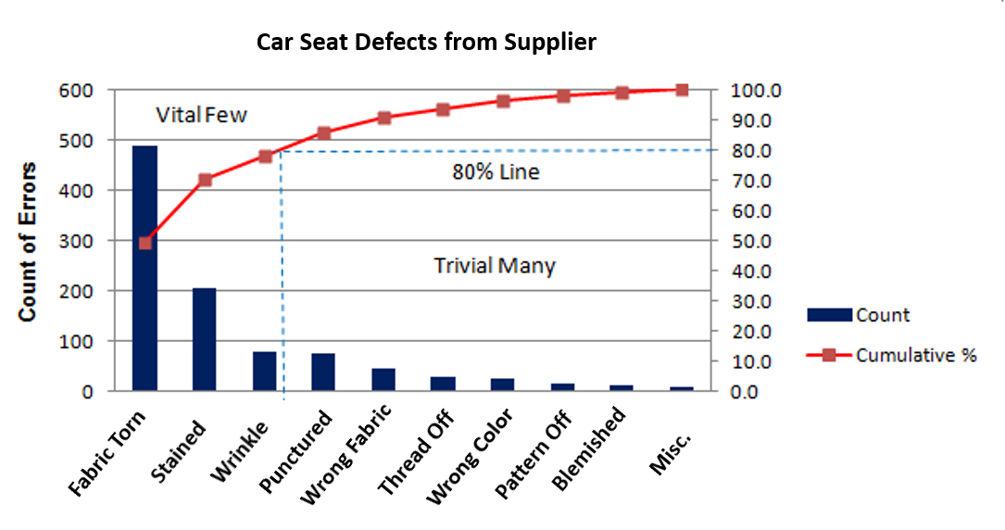

Defect | Count | Percentage
Fabric Torn | 498 | 50.40%
Stained | 200 | 20.24%
Wrinkle | 95 | 9.62%
Punctured | 94 | 9.51%
Wrong Fabric | 50 | 5.06%
Thread Off | 18 | 1.82%
Wrong Color | 15 | 1.52%
Pattern Off | 10 | 1.01%
Blemished | 5 | 0.51%
Miscellaneous | 3 | 0.30%
Total Defects | 988 | 100.00%

Image 6: Run Chart

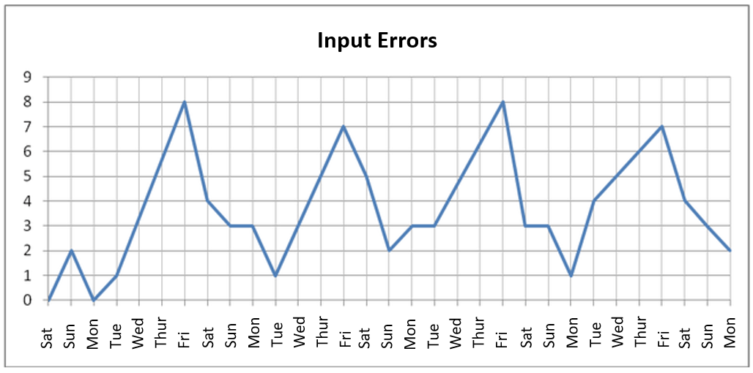

Week | Day of the Week | Number of Defects
Week 1 | Saturday | 0
 | Sunday | 2
 | Monday | 0
 | Tuesday | 1
 | Wednesday | 3
 | Thursday | 6
 | Friday | 8
Week 2 | Saturday | 4
 | Sunday | 3
 | Monday | 3
 | Tuesday | 1
 | Wednesday | 3
 | Thursday | 5
 | Friday | 7
Week 3 | Saturday | 5
 | Sunday | 2
 | Monday | 3
 | Tuesday | 3
 | Wednesday | 5
 | Thursday | 6
 | Friday | 8
Week 4 | Saturday | 3
 | Sunday | 3
 | Monday | 1
 | Tuesday | 4
 | Wednesday | 5
 | Thursday | 6
 | Friday | 7
Week 5 | Saturday | 4
 | Sunday | 3
 | Monday | 2

